**Harika_Wipro_Training_Batch (3)_Sattinder**

Harika

[Jonnalaharika09@gmail.com](mailto:Jonnalaharika09@gmail.com)

**DAY- 1**

Task 1:

Compare Dual Core and Quad Core.

A: When Comparing Dual Core and Quad core processors, Several factors come into play performance, power consumption multitasking capability and cost.

1. **Performance**: Quad core processors are typically offer better performance than dual core processors especially in tasks. The dual core can perform only two tasks while quad core performs four tasks simultaneously. Such as Gaming, Video Editing and multitasking.
2. **Multitasking**: Quad-core processors have an advantage in multitasking scenarios because they can distribute tasks across more cores, leading to smoother performance when running multiple applications simultaneously. Dual-core processors may struggle with heavy multitasking, leading to slower performance or lag.
3. **Power Consumption**: Generally, dual-core processors consume less power compared to quad-core processors because there are fewer cores active. This can be beneficial for laptops and other portable devices where battery life is crucial.
4. **Cost**: Dual-core processors are often cheaper than quad-core processors, making them a more budget-friendly option for users who don't require high-performance computing.

Compare i5 and i7

* Core i5 Processor is dual-core or quad-core, whereas Core i7 processor is dual-core, quad-core, and hex-core processor architectures.
* Hyper-Threading is not possible in Core i5 processors, but it is possible in Core i7 processors.
* The cache size of Core i5 is 3MB-6MB. On the other hand, the cache size of Core i7 is 4MB-8MB.
* The battery of the Core i5 processor last for 14 hours and 45 but the battery of the Core i7 processor last for 10 hours and 49 minutes.
* i5 processors offer embedded options, but i7 processor does not offer an embedded option.

Core i5 is a mid-range processor developed and manufactured by Intel. It is dual-core or quad-core processors. You can use it on both desktop and laptop computers.

Core i7 is a family of high-end performance x86 64-bit processors developed by Intel. It is designed for high-end desktops and laptops.

**DAY – 2**

Binary to Decimal Conversion

128 64 32 16 8 4 2 1 Answers

1 0 0 1 0 0 1 0 146

0 1 1 1 0 1 1 1 119

1 1 1 1 1 1 1 1 255

1 1 0 0 0 1 0 1 197

1 1 1 1 0 1 1 0 246

0 0 0 1 0 0 1 1 19

1 0 0 0 0 0 0 1 129

0 0 1 1 0 0 0 1 49

0 1 1 1 1 0 0 0 120

1 1 1 1 0 0 0 0 240

0 0 1 1 1 0 1 1 59

0 0 0 0 0 1 1 1 15

Decimal to binary conversion

128 64 32 16 8 4 2 1

238 1 1 1 0 1 1 1 0

34 0 0 1 0 0 0 1 0

123 0 1 1 1 1 0 1 1

50 0 0 1 1 0 0 1 0

255 1 1 1 1 1 1 1 1

200 1 1 0 0 1 0 0 0

10 0 0 0 0 1 0 1 0

138 0 1 0 0 1 0 1 0

1 0 0 0 0 0 0 0 1

13 0 0 0 0 1 1 0 1

250 1 1 1 1 1 0 1 0

107 0 1 1 0 1 0 1 1

224 1 1 1 0 0 0 0 0

114 0 1 1 1 0 0 1 0

192 0 1 1 0 0 0 0 0

Address Class Identification

Address Class

10.250.1.1 A

150.10.15.0 B

192.14.2.0 C

148.17.19.1 B

193.42.1.1 C

126.8.156.0 A

220.200.23.1 C

230.230.45.58 D

177.100.18.4 B

119.18.45.0 B

249.240.80.78 E

Network Address

1. 188.10.18.2 & 255.255.0.0 - 188.10.0.0

2. 10.10.48.80 & 255.255.255.0 - 10.10.48.0

3. 192.149.24.191 & 255.255.255.0 - 192.149.24.0

4. 150.203.23.19 & 255.255.0.0 - 150.203.0.0

5. 10.10.10.10 & 255.0.0.0 - 10.0.0.0

6. 186.13.23.110 & 255.255.255.0 - 186.13.23.0

7. 223.69.230.250 & 255.255.0.0 - 223.69.0.0

8. 200.120.135.15 & 255.255.0.0 - 200.120.135.0

Host Address

1. 188.10.18.2 & 255.255.0.0 = 0.0.18.2
2. 10.10.48.80 & 255.255.255.0 = 0.0.0.80
3. 222.49.49.11 & 255.255.255.0 = 0.0.0.11
4. 128.23.230.19 & 255.255.0.0 = 0.0.230.19
5. 10.10.10.10 & 255.0.0.0 = 0.10.10.10
6. 200.113.123.11 & 255.255.255.0 = 0.0.0.11
7. 223.169.23.20 & 255.255.0.0 = 0.0.23.20

Network and Host Identification

Circle the network portion of this address

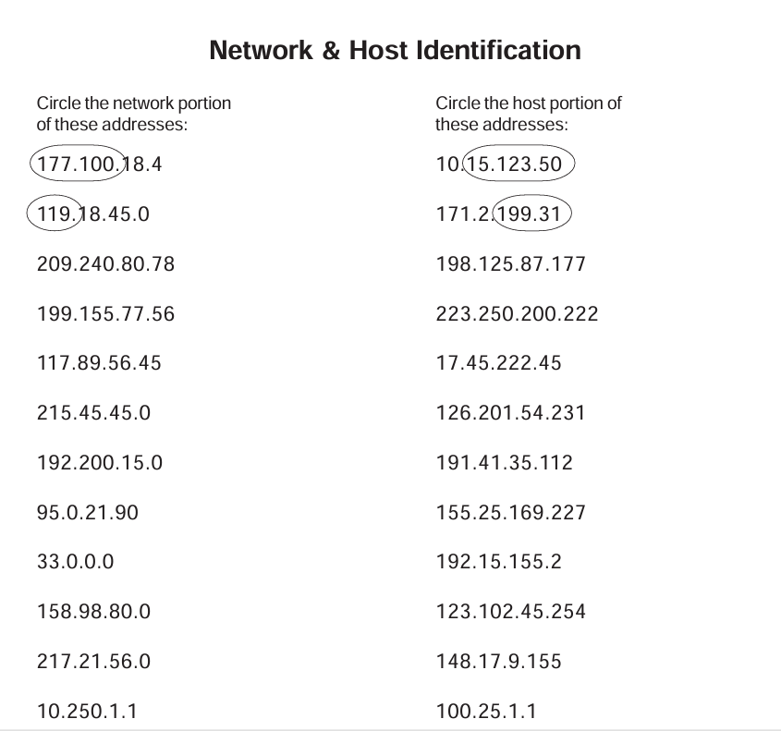

209.240.80 – network address 177 – host address

199.240.80 - network address 222 – host address

177.89 - network address 45.222.45 - host address

215.45.45 - network address 201.54.231 – host address

192.200.15 - network address 35.112 - host address

95 - network address 169.227 - host address

33 - network address 2 - host address

158.98 - network address 102.45.254 - host address

217.21.56 - network address 9.155 - host address

10 - network address 25.1.1 - host address

DAY 3

1. Connect two routers
2. Connect router to switch
3. Connect router with pc
4. Connect PC with Switch

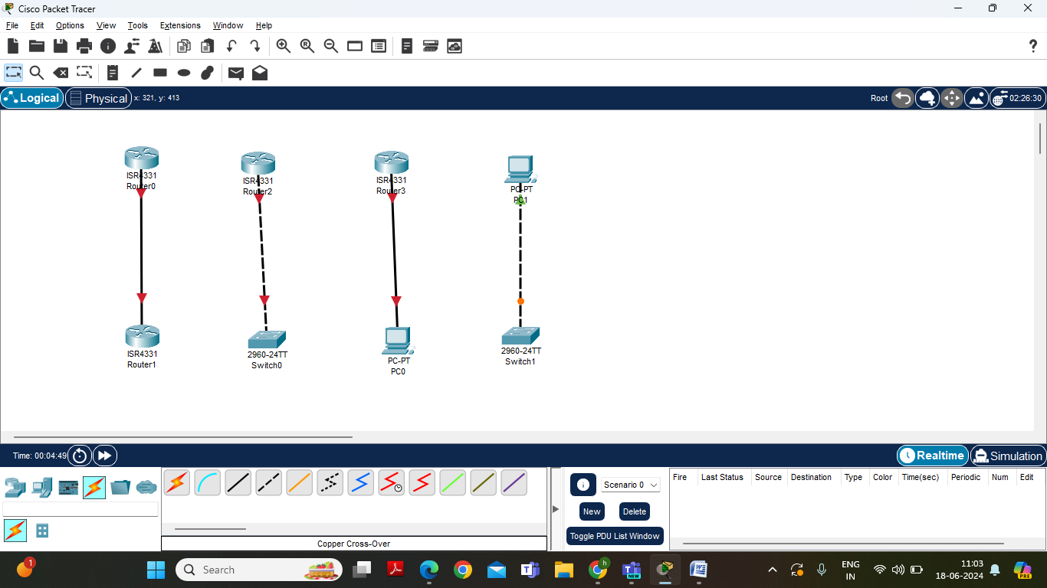

Addressing the IP address for router and PC

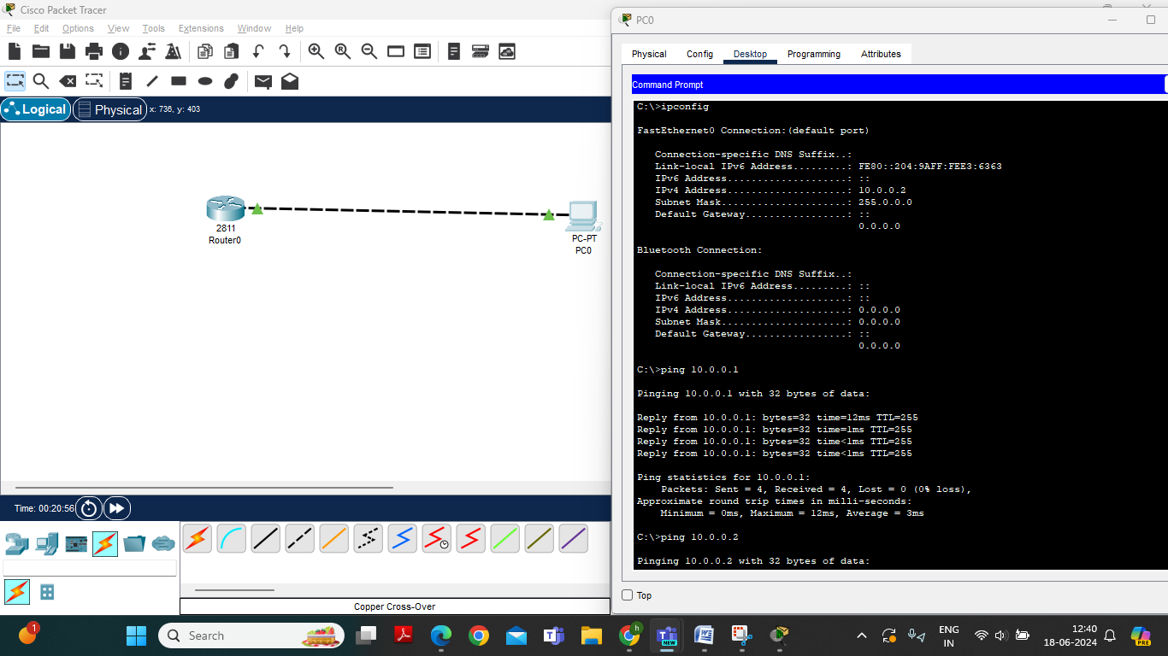

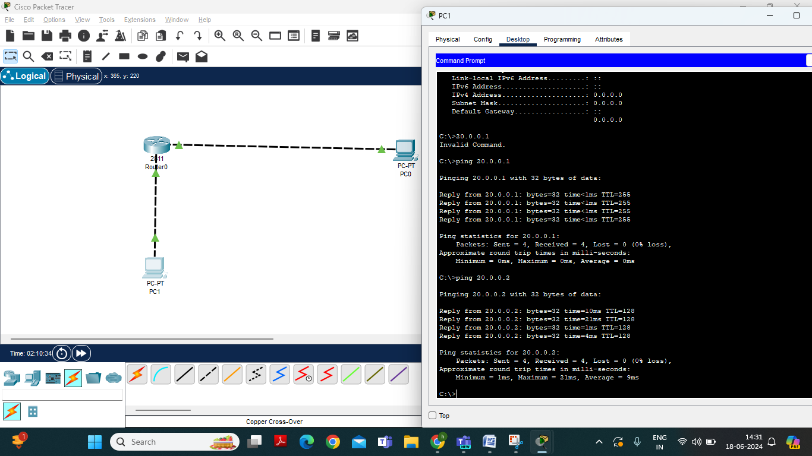

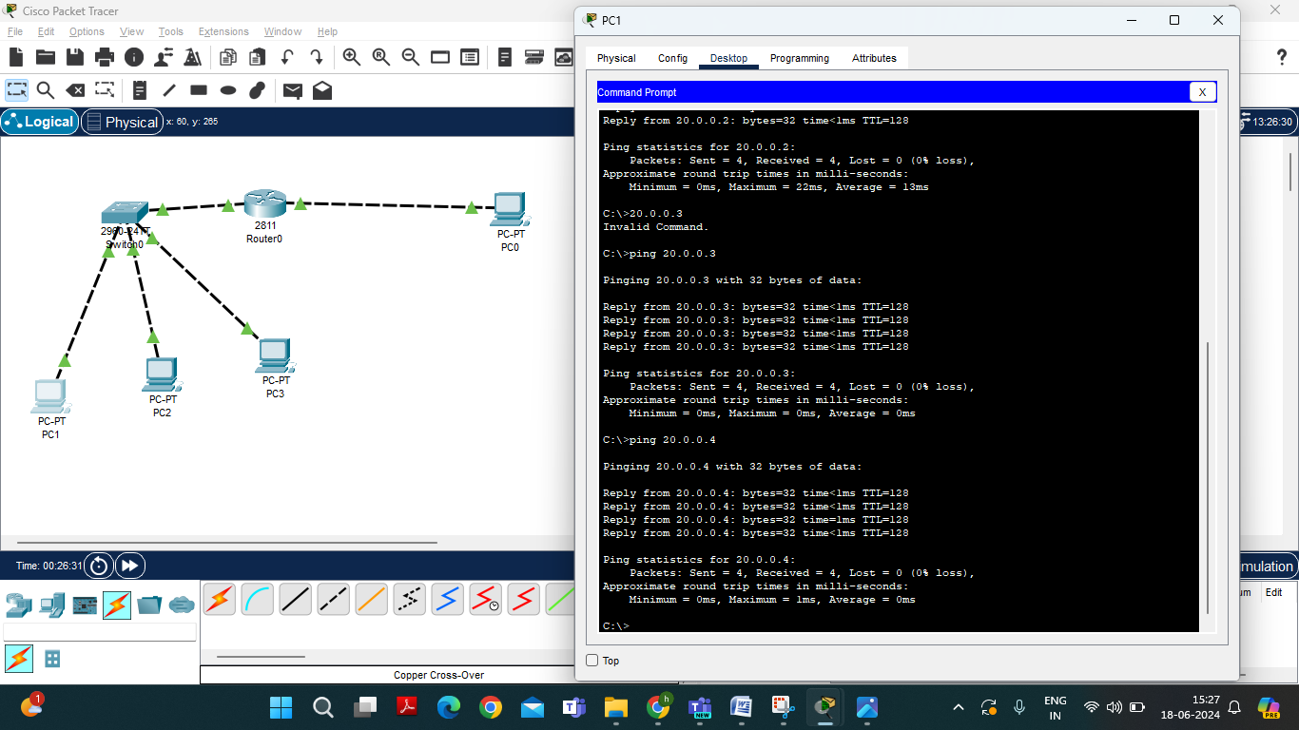

IP address are

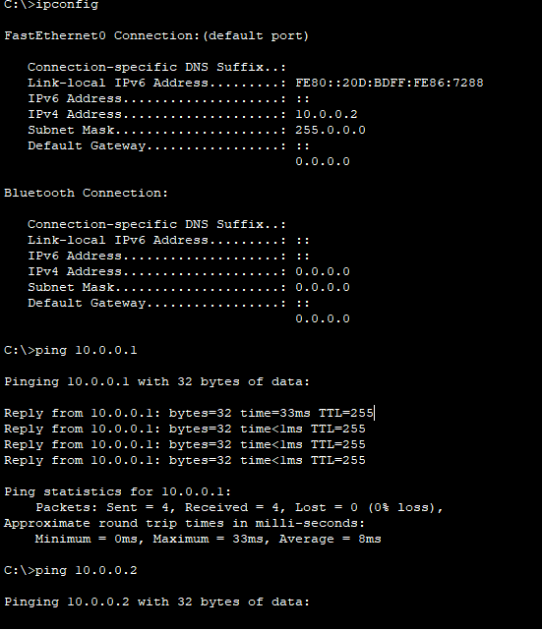

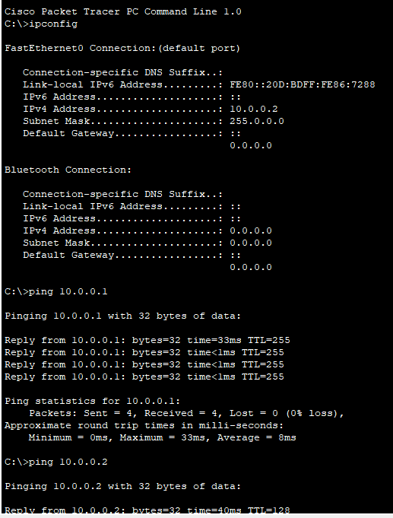

|  |  |  |
| --- | --- | --- |
| Connection | R1- F0/0 | R1- F0/1 |
| PC-0 | Connected | Connected |
| PC-1 | Connected | Connected |
| PC-3 | Connected | Connected |
| PC-4 | Connected | Connected |

**DAY – 4**

Connect Two Routers with Two PC’S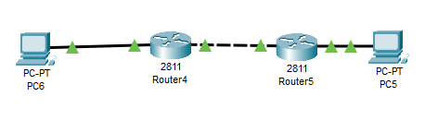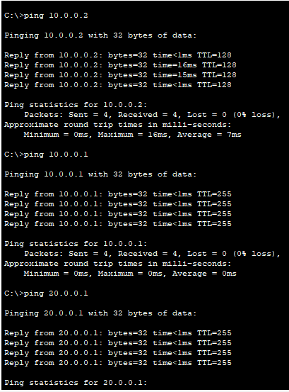

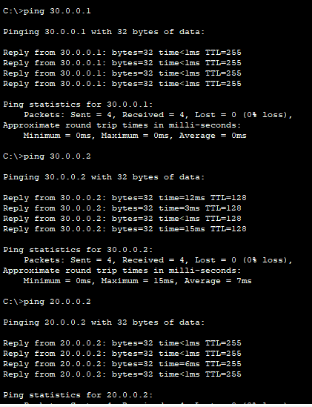

|  |  |  |  |  |
| --- | --- | --- | --- | --- |
| Connection | R4 - F0/0 | R4 - F0/1 | R5 - F0/0 | R5 – F0/1 |
| PC – 5 | Not Connected | Not Connected | Connected | Connected |
| PC – 6 | Connected | Connected | Not Connected | Not Connected |

Adding Routing to Routers

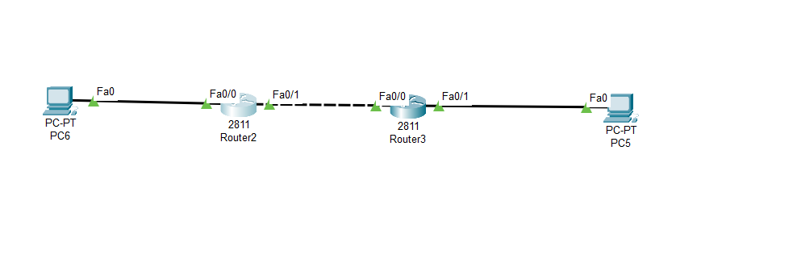

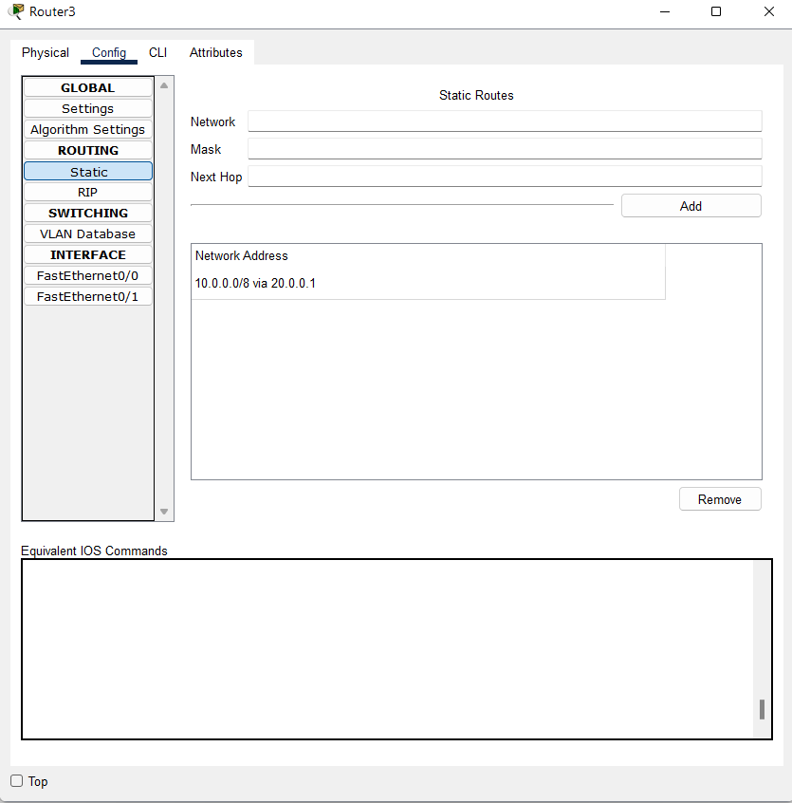

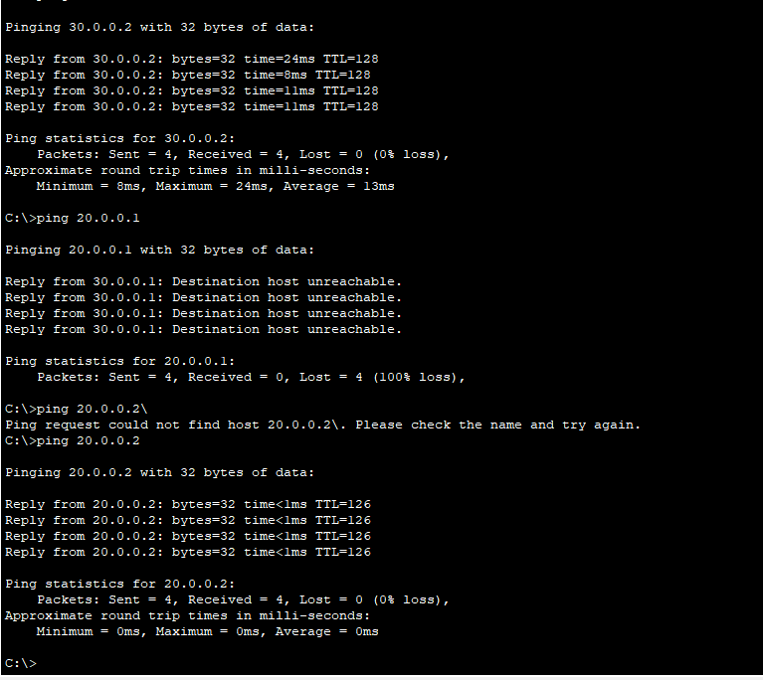

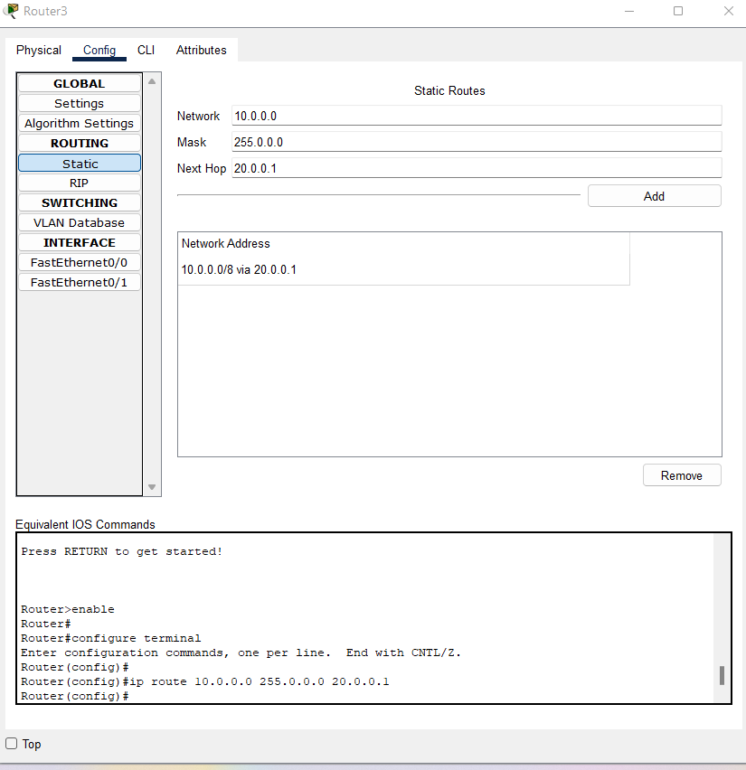

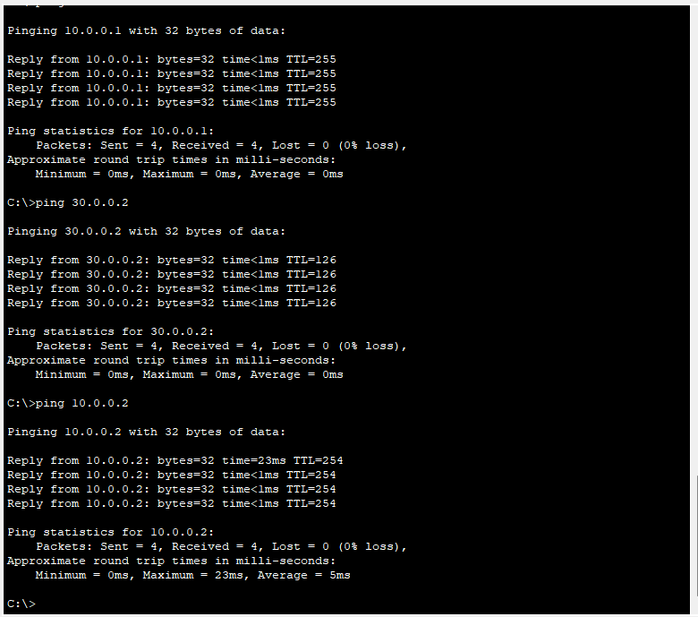

**Day-5**

OSI Layers – Open System Interaction Model

Application Layer - Where Application Can Access the network services.

Presentation Layer - Ensures data is in usable format and data encryption. Session Layer - Maintain Connections and responsible for ports and session.

Transport Layer - Transmit Data using protocols including TCP and UDP.

Network Layer – Decides which physical path the data will take.

Data link Layer – Defines the format of data on the network.

Physical Layer – Transmit raw bit data over the physical medium.

OSI MODEL VS TCP/IP MODEL

|  |  |
| --- | --- |
| OSI MODEL | TCP/IP MODEL |
| OSI stands for open system interaction | TCP/IP stands for Transmission Protocol and internet protocol. |
| It has 7 Layers | It is 4 layers |
| It is low in Usage | It is mostly used |
| It is Vertically Approached | It is Horizontally Approached |
| Delivery of the package is guaranteed in OSI Model. | Delivery of the package is not guaranteed in TCP/IP Model. |
| Replacement of tools and changes can easily be done in this model. | Replacing the tools is not easy as it is in OSI Model. |
| It is less reliable than TCP/IP Model. | It is more reliable than OSI Model. |

OSI Models Protocols and Port Numbers

|  |  |  |  |
| --- | --- | --- | --- |
| **Layers** | **Protocols** | **Port Numbers** | **services** |
| **Application** | HTTP,FTP, SMTP,POP3, IMAP, Telnet | HTTP (80), HTTPS (443), FTP (20, 21), SMTP (25), POP3 (110), IMAP (143), Telnet (23) | Email, web browsing, file transfer, remote login |
| **Presentation** | SSL/TLS, ASCII, JPEG, GIF, PNG | SSL/TLS (443), ASCII (7) | Data encryption, data compression, data formatting |
| **Session** | NetBIOS, PPTP, RPC | NetBIOS (137-139), PPTP (1723), RPC (Remote Procedure Call) | Session management, dialog control, synchronization |
| **Transport** | TCP, UDP | **TCP**-HTTP (80), HTTPS (443), FTP (20, 21), SMTP(25),POP3(110), IMAP (143),SSH(22), Telnet(23)  **UDP**-DNS(53),DHCP(67,68),SNMP(161), TFTP(69),NTP(123) | Reliable data delivery, error-checking, flow control |
| **Network** | IP, ICMP, ARP | ICMP (Internet Control Message Protocol), ARP (Address Resolution Protocol) | Logical addressing, routing, traffic control |
| **Data Link** | Ethernet, PPP, HDLC, LLC | **----------------** | Error detection and correction, framing |
| **Physical** | Ethernet, Wi-Fi, Fiber optics, USB, Bluetooth | **--------------------** | Physical transmission of data |

Using NAT for Routers

